Challenge 01 - HTML

For this challenge, you’ll need to create a whole web page for Apple devices, with implemented CSS styles. Refer to the *screenshots* folder to see the exact look of the page.

Necessary functionality that you should include is that the navbar items should scroll the page to the section they are meant to. Ex. If you click on iPhone, the page is scrolled to the iPhone devices section.

While hovering the navbar items, each item changes its color.

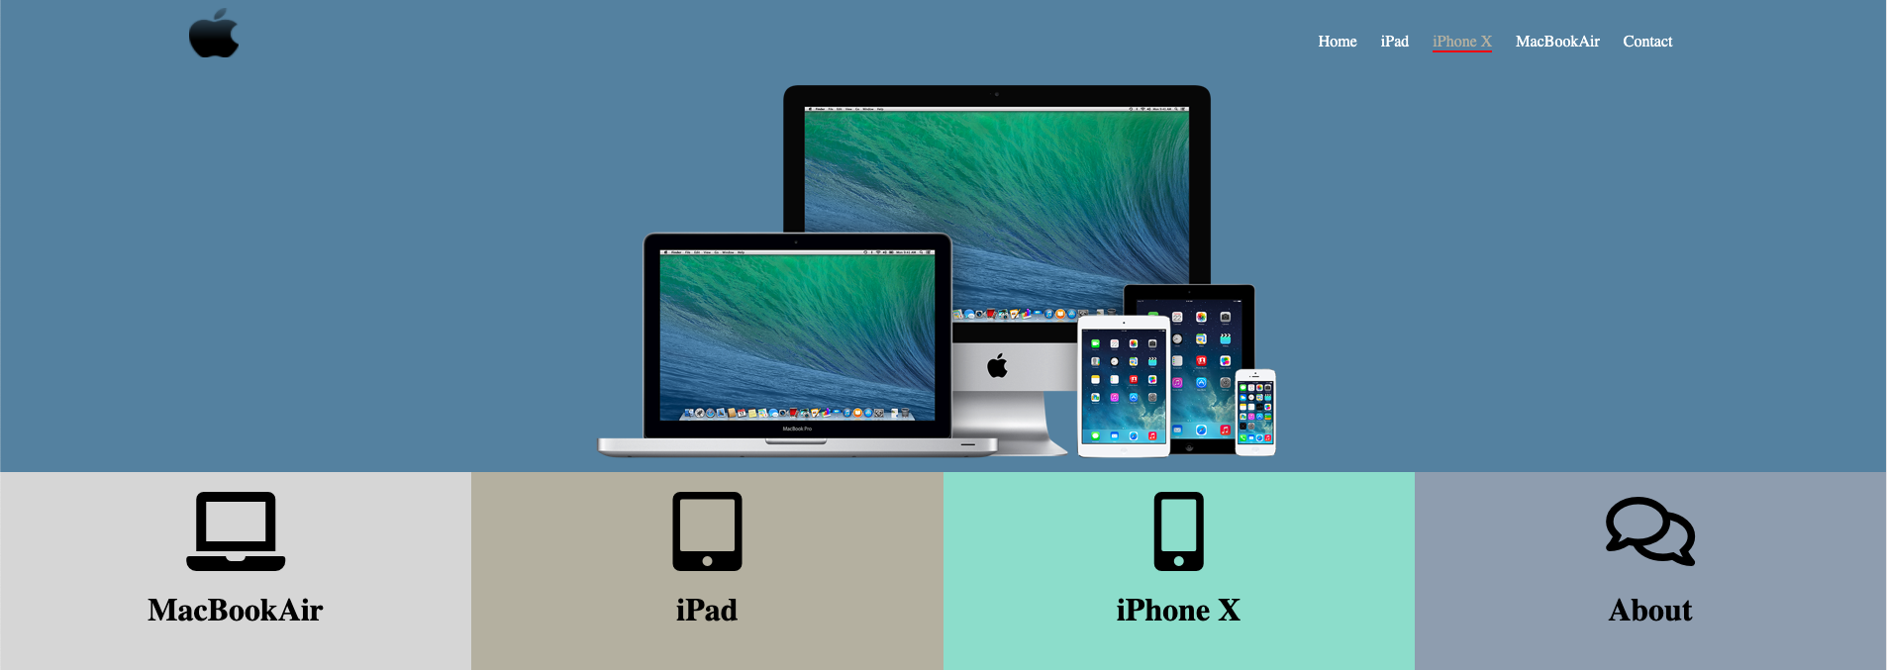

*Screenshot with navbar item on hover*

The social media icons should be font-awesome icons. You wouldn’t be able to gain the 5 points If using .img/.png images.



*Social media icons*

Each of the icons should redirect the user to a valid page that opens in a new tab.

The look for the rest of the page is in the *screenshots* folder also.

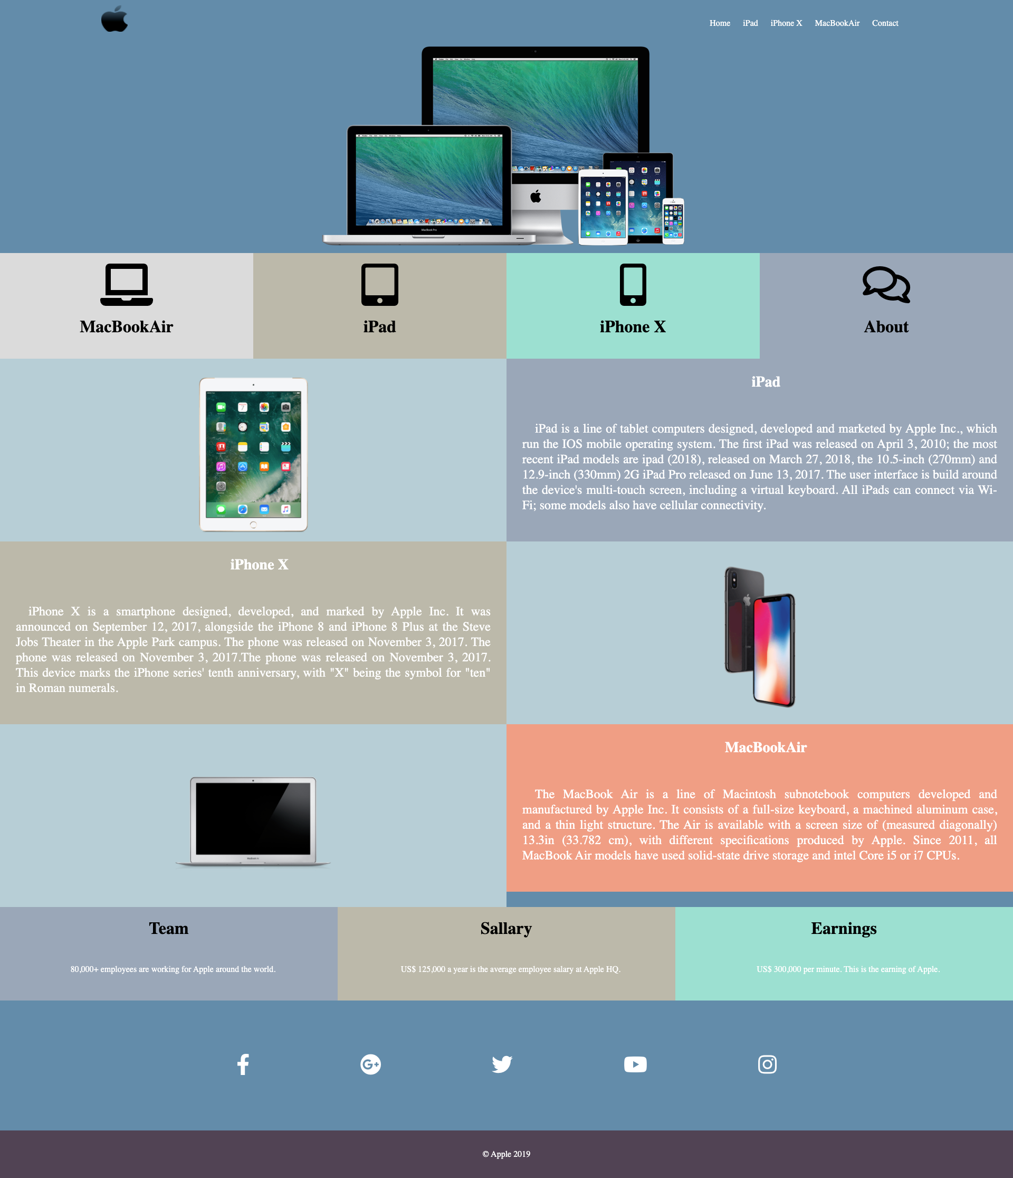

#### 

#### Evaluation system:

1 point - Whole page completed in HTML & CSS.

3 points - Whole page completed in HTML & CSS, social media images are file images.

5 points - All of the links on the page should have valid values that will redirect the user accordingly. The icons for social media items should be done using font-awesome icons and should contain links that will open in a new tab. The items in the navbar will point to their sections.

#### Deadline:

1 weeks after its presentation, 23:59h end of the day.